New Members:
Ralph Rameirez, Aaron Oya and Dennis Lake. Mahalos… Dennis has been building for many moons and UGH welcomes his presence in the Guild roster. Looks like the Big Island has garnered some awesome and experienced builders who have chosen to make the Big Island their home base.

UGH BUSINESS

Our June officer’s meeting was devoted solely to the upgrading and organization of the November UGH Ukulele Exhibition. We have hammered out a tentative three-day schedule of events, which follows:

COSTS:
a. ENTRIES
Entries into the exhibition will be charged $25.00 per instrument and be limited to three instruments per member. Entries are limited to Guild members only.

b. VENDORS AND SUPPLIERS
Cost for Vendors or Suppliers will be $100.00 per table with a three-table limit.

c. SCHOOLS AND EXHIBITS
Cost for schools will also be charged $100.00 per table and include a three-table limit.

d. All entries that are sold at Exhibition will be subject to a 10% charge, which will go into UGH coffers.

e. Exhibition T-shirts will be on sale to all in attendance at a cost of $15.00 per shirt.

f. UGH Polo Shirts will be made available to Guild members only at a cost of $20.00 per shirt.

SCHEDULE OF EVENTS:

Friday, November 15th.

9:00 am
Doors open. Exhibition setup committees be present:
- Set-up crews: plants…tables, stands, banners, placards sponsor ads and programs.
- Vendors and Table Exhibitors.
- Registration and Name Tag Committees.
- Guild Polo Shirts and Exhibition T- Shirt Table set-ups.

10:00 am – 12:00 pm
Check–in and registration of all instruments.

Continue set-up until 5:00 pm.

Arrange pupu tables for evening Members only Event.

6:00 pm
Event begins with Members and invited guests only for pupus and entertainment.

COSTS:
UGH Members - $25.00
Guests - $15.00 Friday nite EVENT only.
6:30 pm
INVOCATION

6:35 pm
Emcee – Introduction of Officers and Directors and Special Guests.

View Exhibition, talk story, pupus, no host bar and entertainment. Both Professional and Member driven.

9:00 pm
Closing of Exhibition.

SATURDAY NOVEMBER 16TH

9:30 am
Doors open to the public.
Security Committee to be at door.

Registration Committee – set up calabash for entry donations to the Guild. Programs will be available along with T-shirt sales.

EXHIBITION open to all from 9:30 am – 9:00 pm.

Entertainment on ground floor as well as EXHIBITION floor through out the day: with Halaus, ukulele players, guitarists, and various groups. See Miki Browne if you have volunteers.

The Guild would like to schedule two morning seminars and or demonstrations and two evening seminars on Saturday.

10:00 am
Seminar till 11:00 am

1:00 pm - 2:00 pm

6:00 pm - 6:45 pm

7:00 pm - 8:00 pm

SUNDAY NOVEMNER 16TH

9:30 am
Doors open.

10:00 am - 11:00 am
Seminar

11:00 am – 12:00 pm
Ukulele Guild Auction

1:00 pm - 3:00 pm
Pack up and take home EXHIBITION ukuleles.

3:00 pm - 5:00 pm
Take down show. Secure loading area.

Entertainment throughout Sunday from 10:00 am - 3:00 pm.

O.K. Members that’s about the gist of it.

So now comes your part. We need volunteers to host the various seminars. What would you like to see demonstrated? Here’s some officer-generated ideas:

1. Laser work design set-up and execution.

2. Rope binding demonstration or back strip composition.
3. Finishes: French polishing, oil finishes, Spray finishes (lecture only on this one) Hotel would faint with lacquer fumes.

4. Soundboard choices and tap toning or frequency generation.

5. Action and final set-up to include dressing of fingerboards.

6. String Theory.

7. Kamaka Factory tour?

8. Design considerations in ukulele making.

9. Alternate soundboard bracing: i.e. Lattice, or Kasha Schneider.

Call the Guild at 847-1541 if you want to volunteer for a seminar or would like to see another subject covered.

Other ideas - How about having the Auction on Saturday evening instead of Sunday?
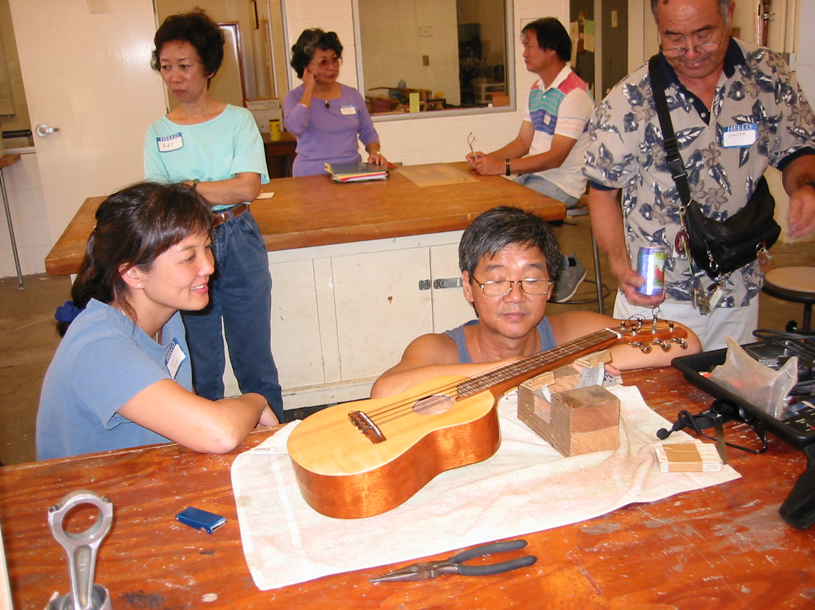
Are we missing any important details? Well people it’s a start in the right direction and we will need to start working on this event right away. So get busy on your instruments!

UPCOMING EVENTS

June 27th - At Orvis Theatre Thursday at 7:30 pm. Gonsalves on Guitar.

June 28th - At Orvis Paul Meyers with Byron Yasui - Jazz Guitar at 7:30 pm.
June 29th - at Orvis 7:30 pm. Classical via Denis Azabaric.

July 13th and 14th - Big weekend at Windward Community College. Daily for two days, all the master players and some great instruction abound. Cost $150.00 for the two-day event.

July 20th - at McKinley High School Woodshop. Binding seminar at 1:00 pm. Hosted by Miki Browne and Mike Chock. Bring pupus.

Nov.15th thru 17th - First Annual Ukulele Exhibition at the Marriott Waikiki Beach.

UGH FORUM

Many Mahalos to Emil Bader and Nate Ching for their excellent workshop demonstrations on Fret installation and action setup. With bruddah Nate’s special tools housed in a neat attaché case, I thought I’d hear harmonica riffs and a Blues Brothers solo. Since there was no handcuffs on his wrist I should have suspected that the attaché was just
a great way to keep specialized tools organized and at hand.

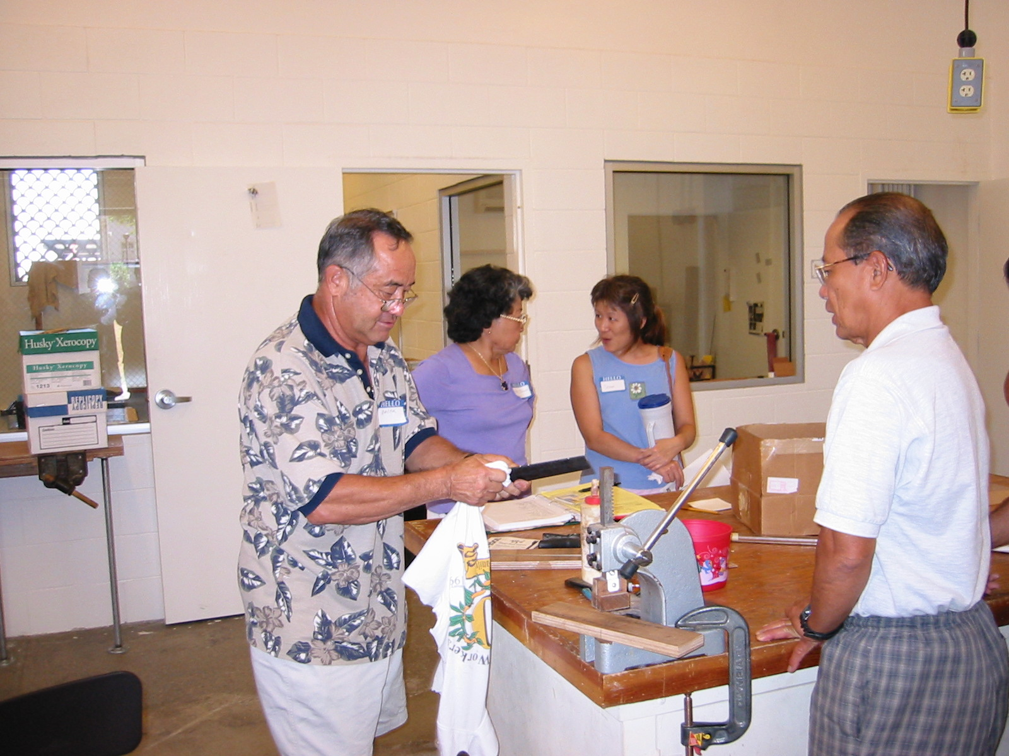
All members who attended certainly benefited from the years of repair
experience that Nate shared and the ingenious jig making ability of
Emil converting a simple press into a valuable fret installation tool.

Of course as always the UGH officer’s were all present and accounted for and a phat mahalos to them for really doing such a great job and donating their time. A considerable amount I may add and energies into making our newly formed Guild function smoothly and efficiently. Remember that this is all unchartered grounds and the officer’s and directors play a huge role in keeping the Ukulele Guild of Hawaii both interesting, educational and self-sustaining.

As usual the pupus were both abundant and onolicious. As an expert on these matters take my word and come and partake of the pupu spread to fully be cognizant of the delicacies being offered. It’s also fun to see Lisa’s woodshop taking shape as the State’s Renovation of her woodshop is slowly, really slowly, but nicely taking shape. Lisa’s dust collector has a motor that could power a small nation and the sucking power to empty a million extra large slurpees in a mini second.

So once more a reminder that the Ukulele Exhibition is on the horizon. Believe me, November will swing by faster than you think. So choose your woods and get started on your entry. We want to be able to show to the public the vast pool of talent that abounds in these islands are representative of the venerable ukulele.

Post Script… already donated to the Guild is a Cocobolo back and sides with spruce top tenor Ukulele via Mike Maldi of Kaimana Ukuleles. Will have this puppy available at the auction. Much mahalos to Mike.

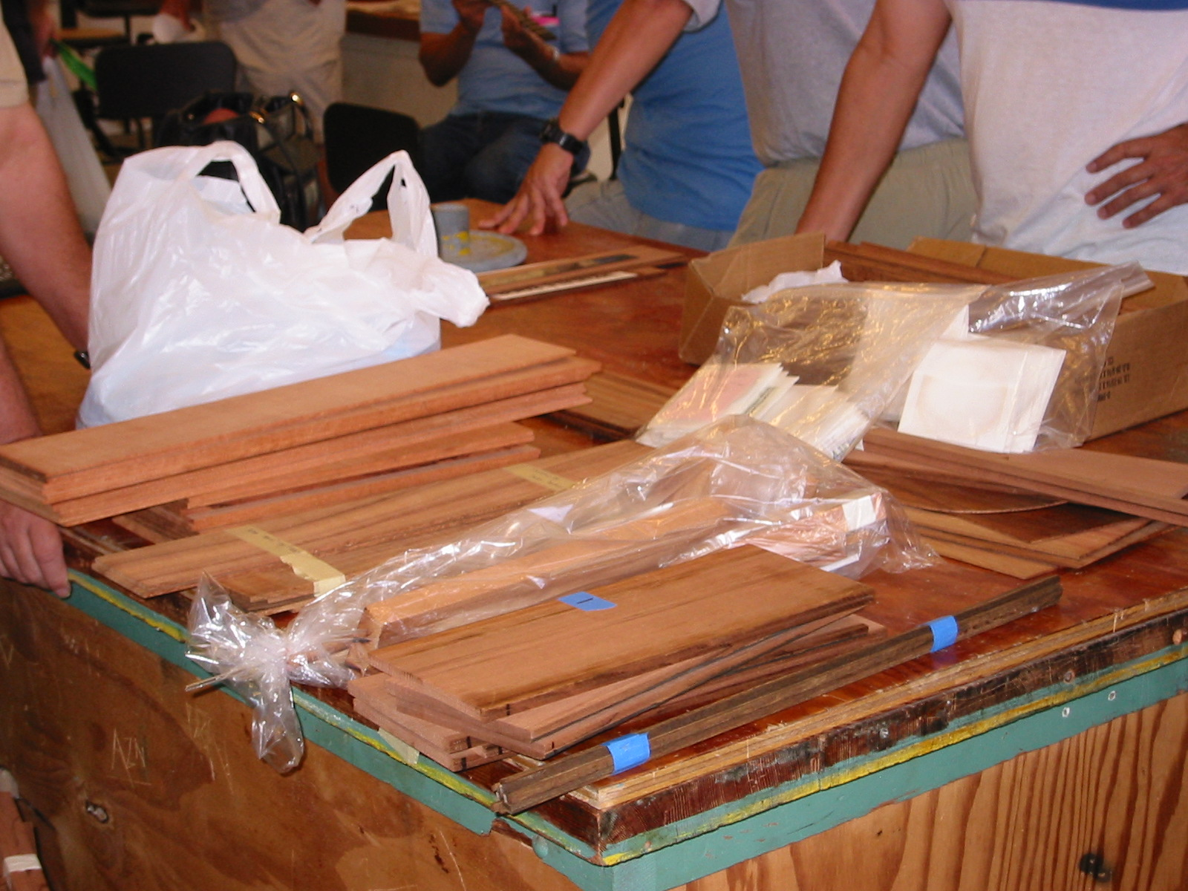
TRY DIS

For you spray finishers here’s a simple means to cover the soundhole prior to spraying your instrument with finish. Buy a packet of kiddie
balloons, choose a nice color, blow em up a bit bigger than your soundhole diameter and stuff the balloon into the hole. The balloon will wedge in quite nicely. After your spraying session you can pop the balloon and find out physically how thick or thin you are spraying by measuring the mil thickness of the finished skin that was on your balloon.

MIKE’S CORNER

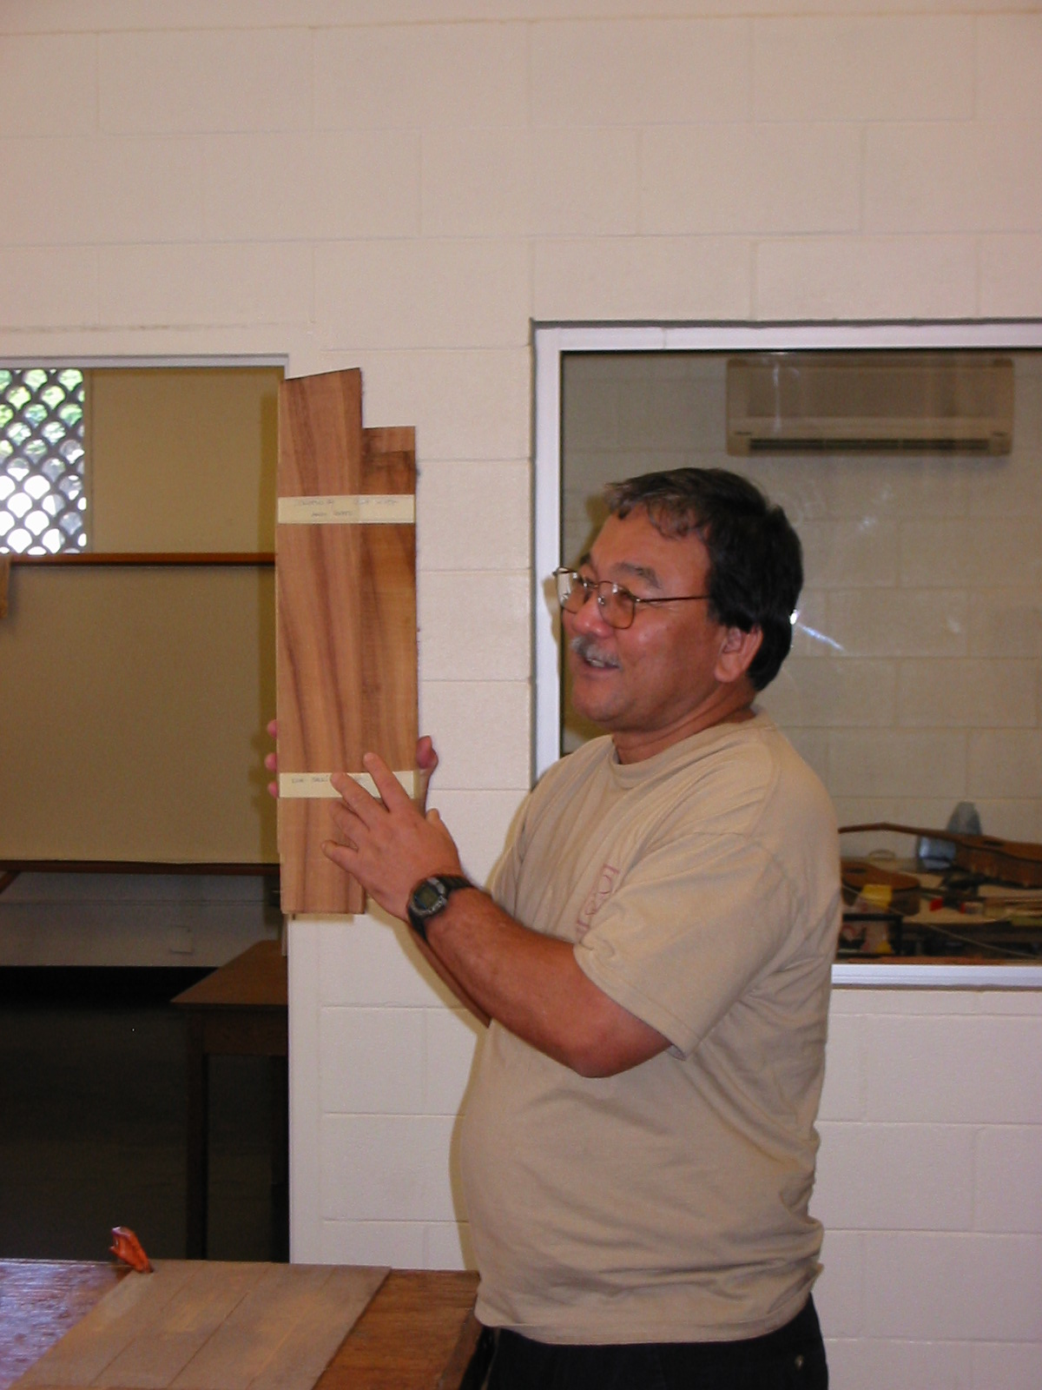
Aloha people! Boy… in between class sessions now and with a month break from teaching you’d think I would delve right into uke construction, but noooooo! Had the bright idea of renovating my wife’s studio at home and have spent 2 weeks in classic grunt work and construction. After a thousand trips up and down 36 steps bringing old materials down and new ones up, I’ve applied for Sherpa status in the local mountain climbing club. I’ve come to distinguish materials by weight and not cost. Thumbs down to wet T-1-11 douglas fir plywood, 70 lb. Bags of Quik Crete, any and all gypboard and wet 2x6 x 16s. Kudos to plastic guttering and downspouts and hurray for prefab sliders. Oh the Brai torch on roofing is awesome, but come on, the rolls are over a 100 lbs. each. Thank goodness roofing nails are light. Anyway you get the picture. The good part is that as of today it’s over. Save for one countertop and a couple of speaker mounts. Which after the ramblings done brings me back to case and point. I do love ukulele making. ”construction without the weight” Hooray! I love my shop. All the proper tools await and the machinery all works… pencils abound and the chisels are sharp. So never more a bitch from my lips. Just takes a bit of working in another pair of shoes to keep the focus sharp.

So for all you builders out there who after an eight-hour day of labor, retreat to your workshops for therapeutic ukulele construction my hardhats off to you. Keep the spirit up and continue the great work.

Been getting firsthand looks at member Wayne Nakashima’s uke set stash. The bruddah has been busy and his uke sets are truly worthy of envy and lust. Which means all the members who partook of his pallet of Big Island Koa are smiling widely as well. The Guild Humbly awaits your offerings. Heavens am actually in the final throes of uke completion. The series that has graced my shop for lo over seven months is almost pau.

Clarence Uesato and a back/sides set via Bruddah Wayne.

So I admit, I am proof positive in the adage… “Do as I say…not as I do” Happily in the Hana Lima Ia work sessions the Ukuleles actually get finished in a timely manner. Ok people, will close now and happily get back to work. Keep your strings tight. Aloha, Mike

AL’S MAGICAL MUSICAL MOMENTS

Aloha …back in the saddle once more. Thought I’d follow up on ukulele introductions with a few selections of progressions in the key of C. Try these progressions out for size:

Open C6 to G Diminished to Dm to G Augmented or G7

Or a minor attack:

Em to Am to Dm7 (second position) to G Augmented or G7 (second position)

Or how about?

Cmaj. 7 to G Diminished to Dm7 to G Augmented or G7
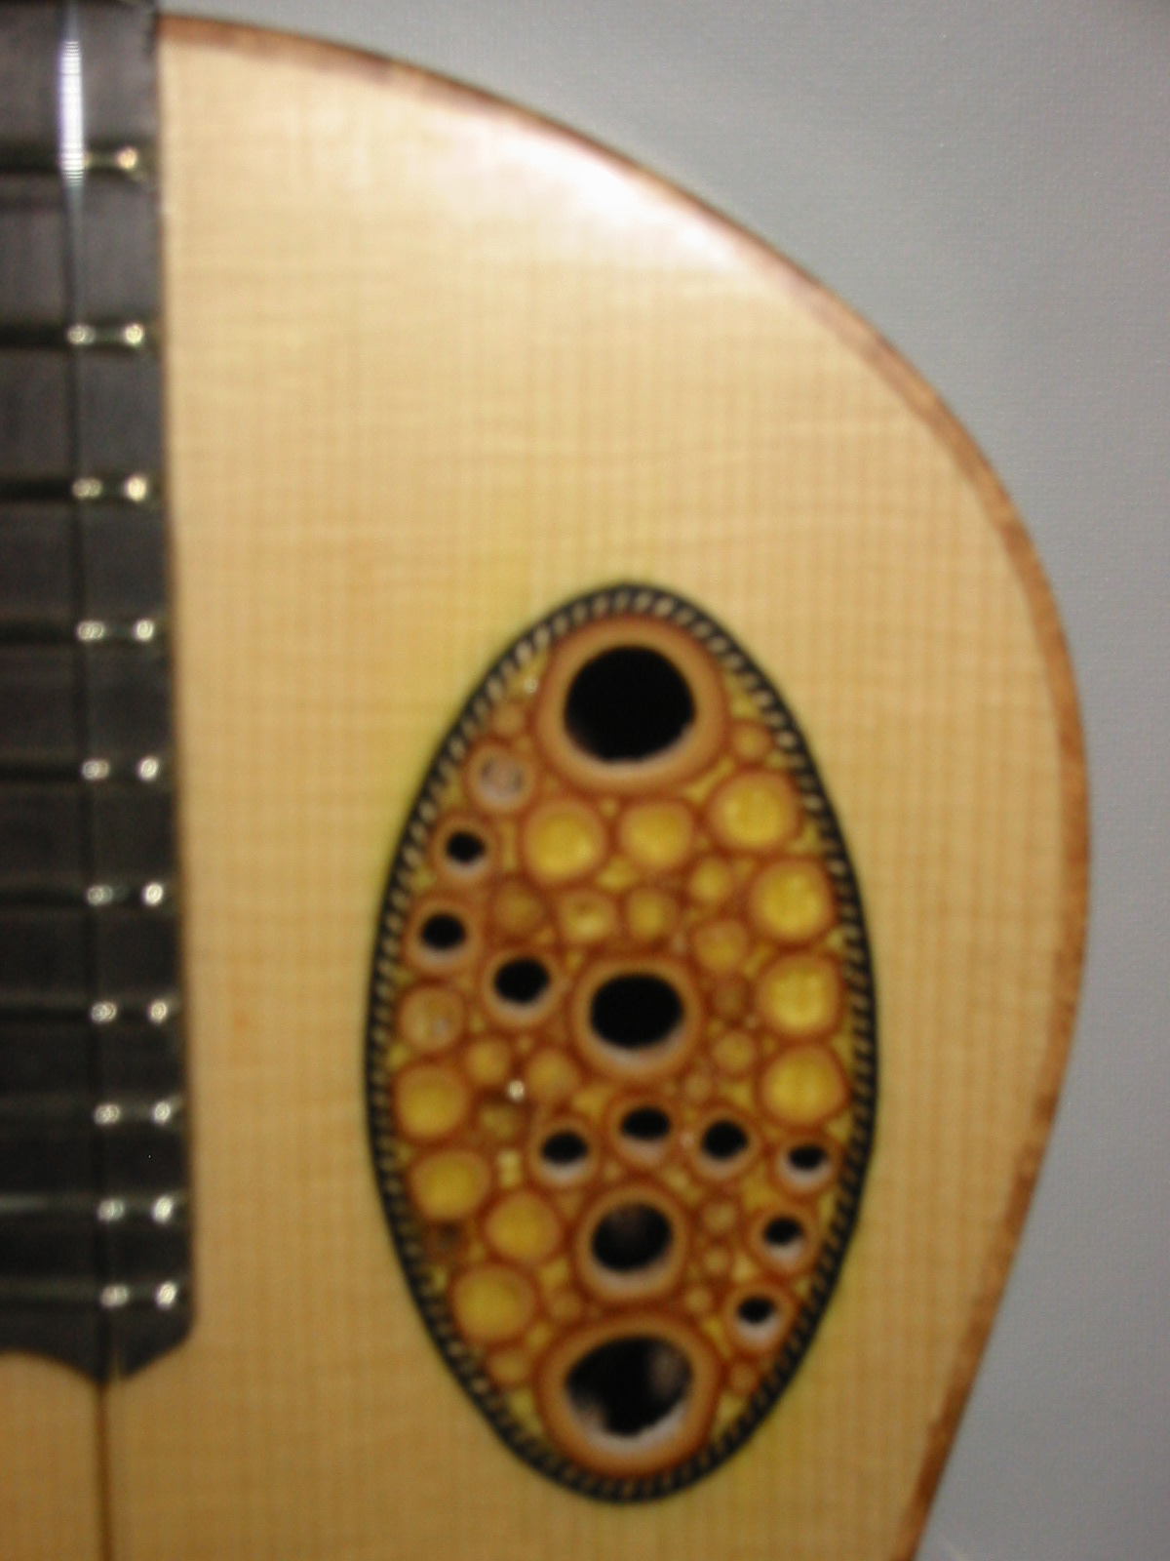
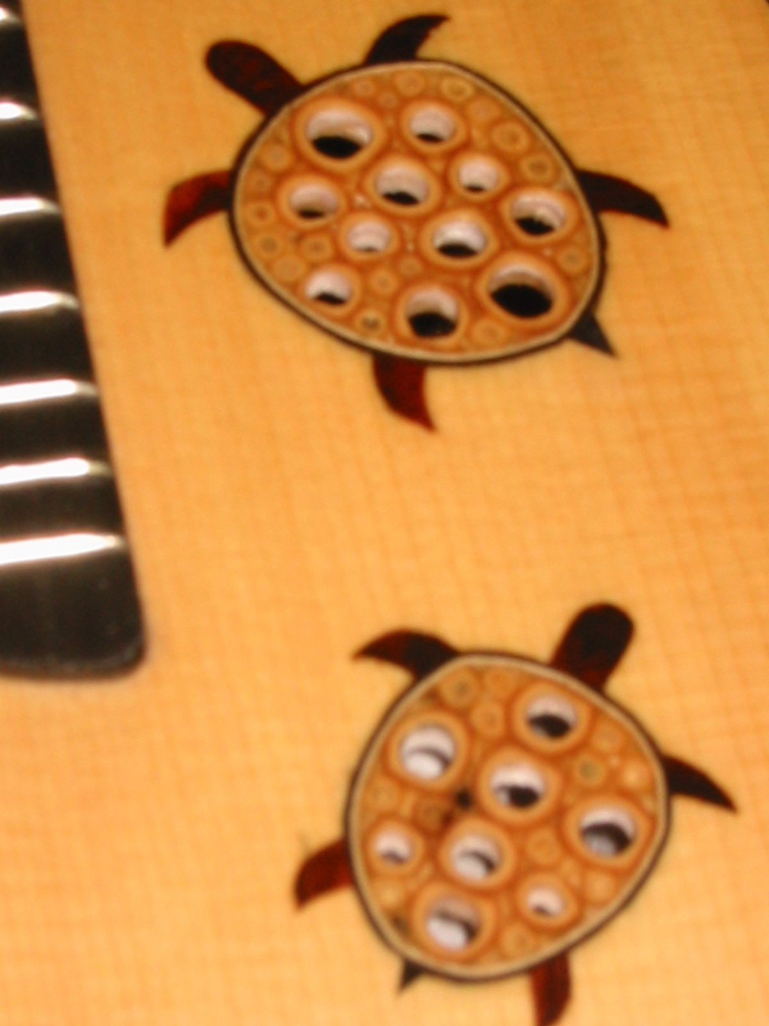
The above go together well with:

C6 (second position) to C Diminished to Dm7 to G7

Or in a higher register:

C6 (third position) to C Diminished (second position) to Dm7 (second position) to G7 (second position)

Try play around with these intros and use them when you see fit. Mix and match. Their yours to use.

Mahalo and Have fun!
Bruddah Al

A POST SCRIPT FROM MIKE’S CORNER

Here’s some quick photos of those ukes that have been hanging in my shop for lo these many moons. Yup the bamboo series are nearing completion and no these ukes were not permanent wall hung décor.

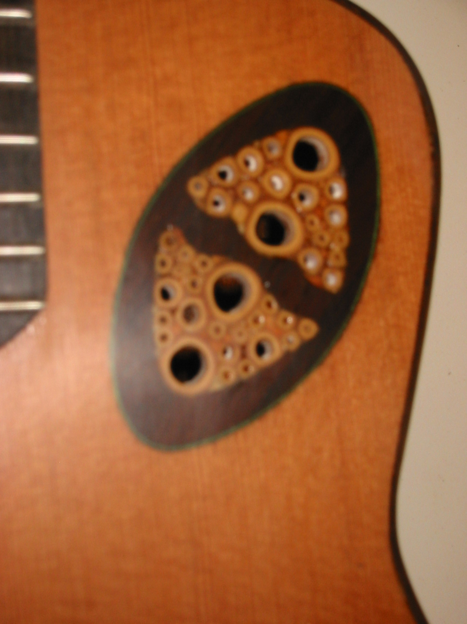
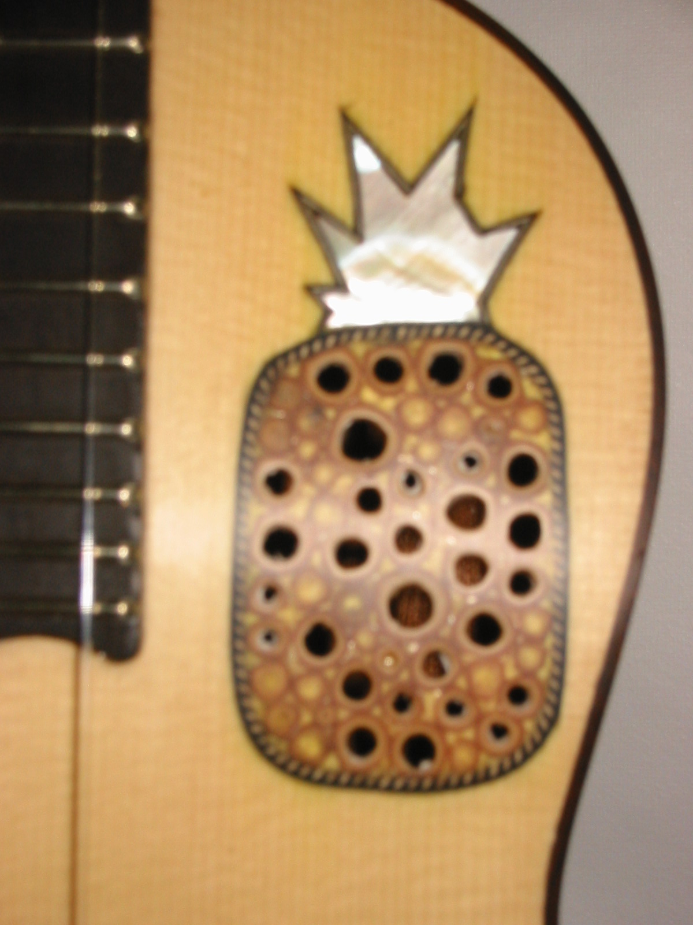
Bamboo series inlay. Need an owama pole a backsaw and you’re in business.

End grain is interesting texture.
UGH West Hawaii Region News
July 1, 2002
(By Andy Berard)

Our membership in the UGH continues to grow. As of May 2002 our membership in the UGH is about 27. We are still recruiting members interested in the guild's process and objectives. Get the word out…mahalo.

UGH West Hawaii Region Calendar
July 13 12:00 to 4:00 pm Quarterly Meeting
October 12, 2002 12:00 to 4:00 pm Quarterly Meeting
November 15-17 UGH Exhibition & Conference Marriott Hotel - Waikiki Oahu

Our next quarterly meeting is scheduled for July 13, 2002 at 12:00 noon at O Kona Ukuleles & Guitars workshop. We should be finished by 4:00 pm, which will allow us all to get home before dinnertime…Our tentative agenda is as follows:
1. Sound Forum review - videotapes available
2. UGH 1st Conference Exhibition - Nov 15-17
3. Treasurers Report - Rance Pinao
4. Side Bending methods - heat pipe, silicone heat blanket, universal side bender.
5. Binding Routing Jig - Using jig built to LMI fixture using a laminate trimmer. Allows one to rout binding on instruments with substantial radius top or back.
6. Joining of sides and getting a perfect joint every time!
7. Swap meet time - Time set aside for selling or trading items. Bring that extra tool or jig that you have no further use for and maybe someone will trade with you or buy it. It is requested that you donate about 10% of all sales to the UGH West Hawaii Treasury to help us raise needed funds. We will also gladly accept donations to the UGH for auction to our membership.
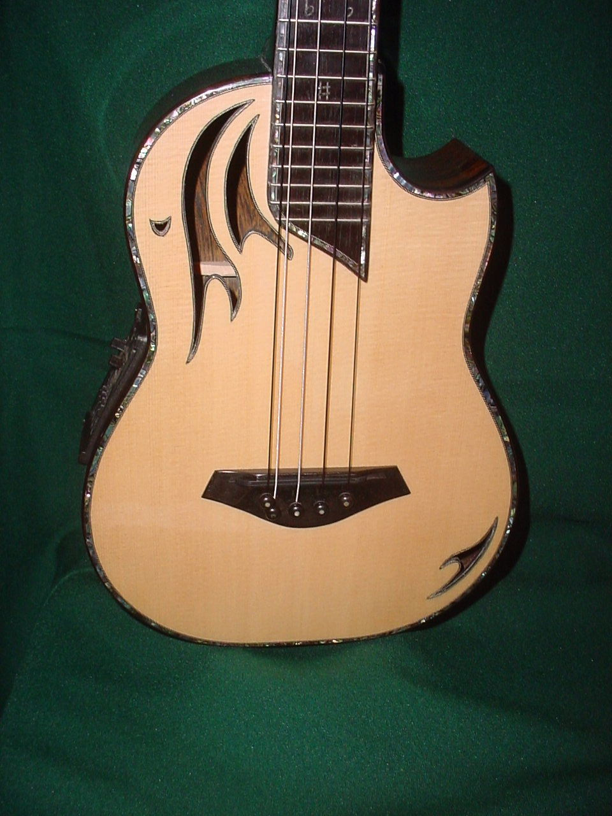
8. Voicing of an instrument - considerations that a builder can control to achieve particular sound characteristics of their instrument.
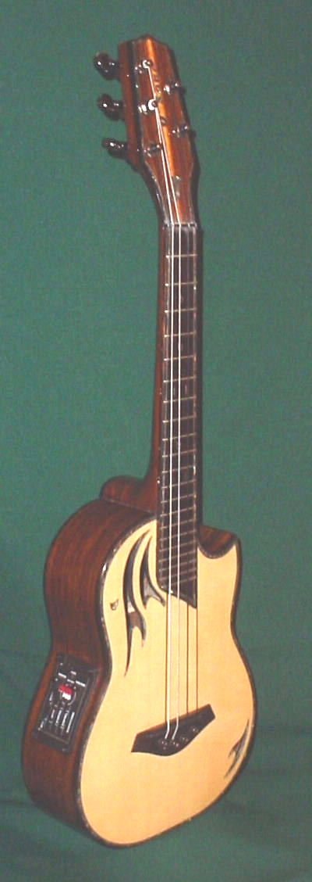
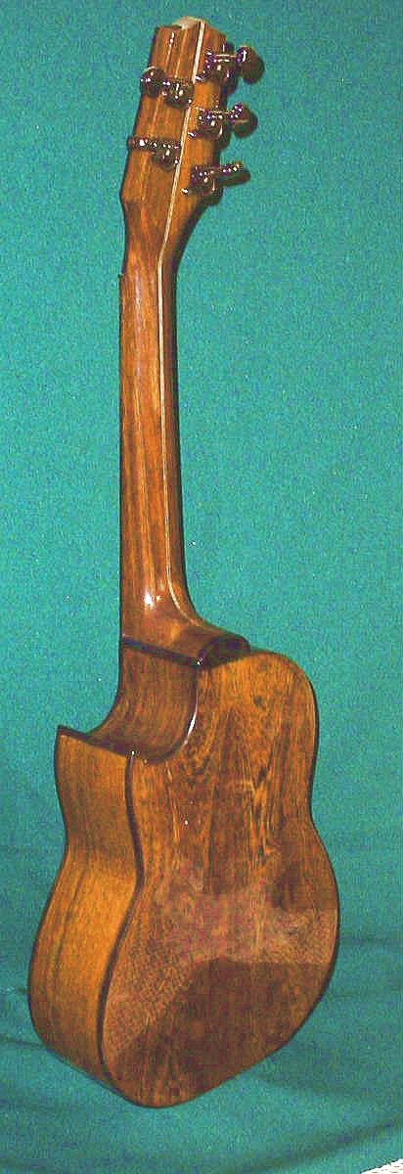
One of our latest creations from O Kona Ukuleles built for Jessie Kunishige of Hamakua Hawaii is provided for your review. It is a 5-string tenor ukulele made of pheasant wood and spruce. The custom top was designed by Jessie and built by Andy. The sound hole design was reinforced with spruce patches across the vertical grain of the top for strength and cutout on the scroll saw. The top was braced with a modified X brace to accommodate the cutaway design and supplemented with three long symmetrical fan braces for support. We also added two cutoff bars in a Vee pattern for support. The soundhole cutouts was lined with black/white/black purfling (about 4 hours) to protect the softer spruce top edges. Wouldn't recommend this design without being sure that your costs are covered.

The back, sides and neck are made out of Pheasant wood (Cassia siamea), which originated in Southeast Asia. It has a specific gravity of .6 to .8, machines well and is fairly stable. Cost is a bit on the high end from $35 and up per board foot. The top is made with Englemann spruce inlaid around the edge, fretboard and headstock with greenheart abalone shell. Fretboard and bridge are made of ebony, and we included a Fishman Matrix Prefix Pro
equalizer. Hilo strings are used and the G course has the octave pair of strings. The sound of this instrument is exceptional with great volume, sustain and projection.
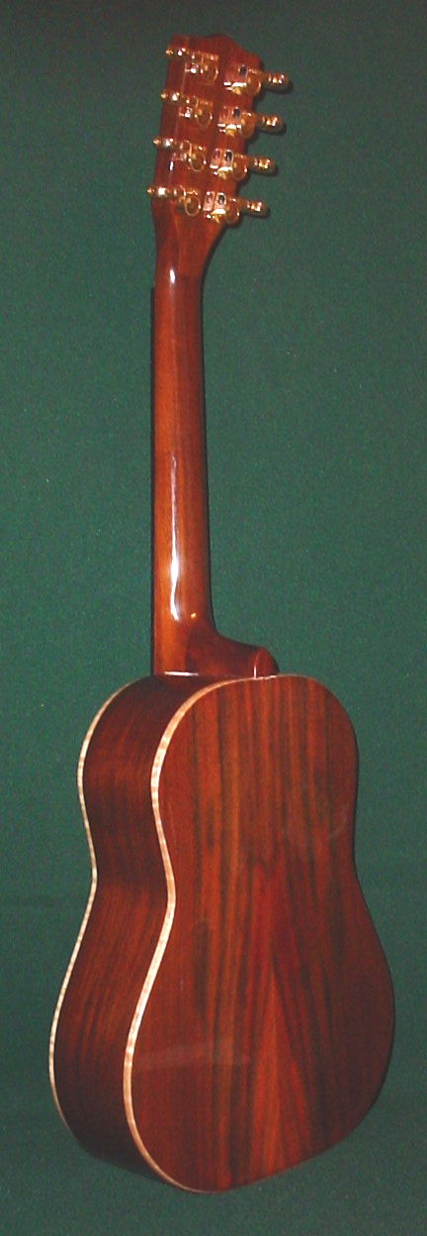
Here are some ukuleles that are near completion by members of the UGH attending O Kona Ukuleles & Guitars Ukulele Building Class:
Rear View of Dennis' Milo Uke with gold Grover keys installed. The grain pattern, color, and contrast with the curly maple binding is just beautiful. Need to see the picture in color to do it justice.

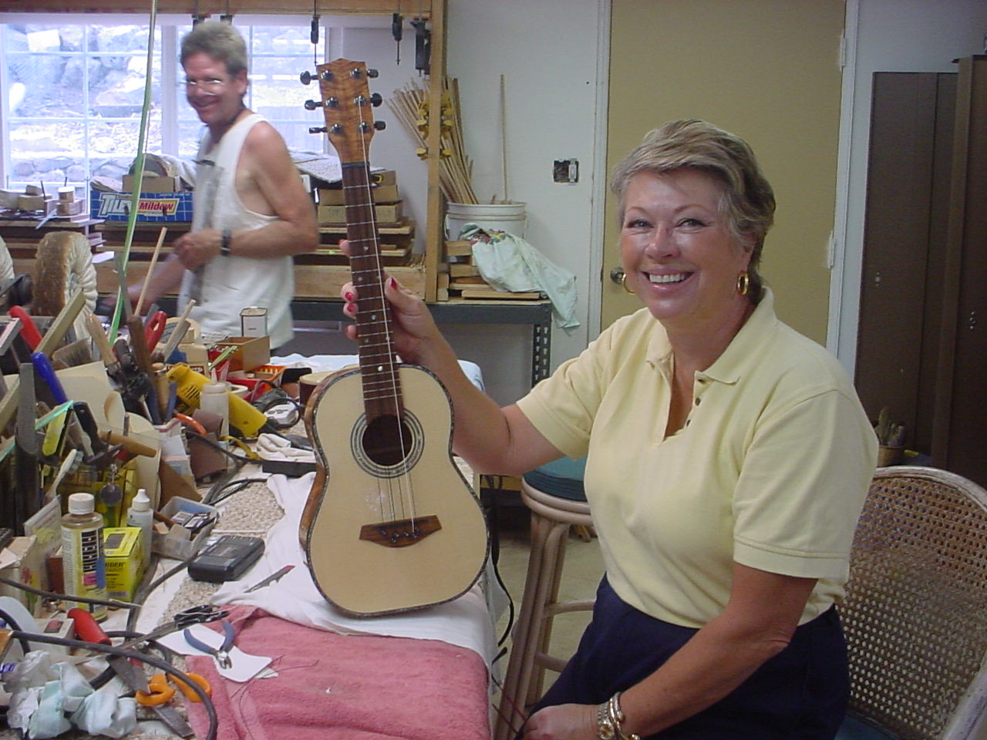

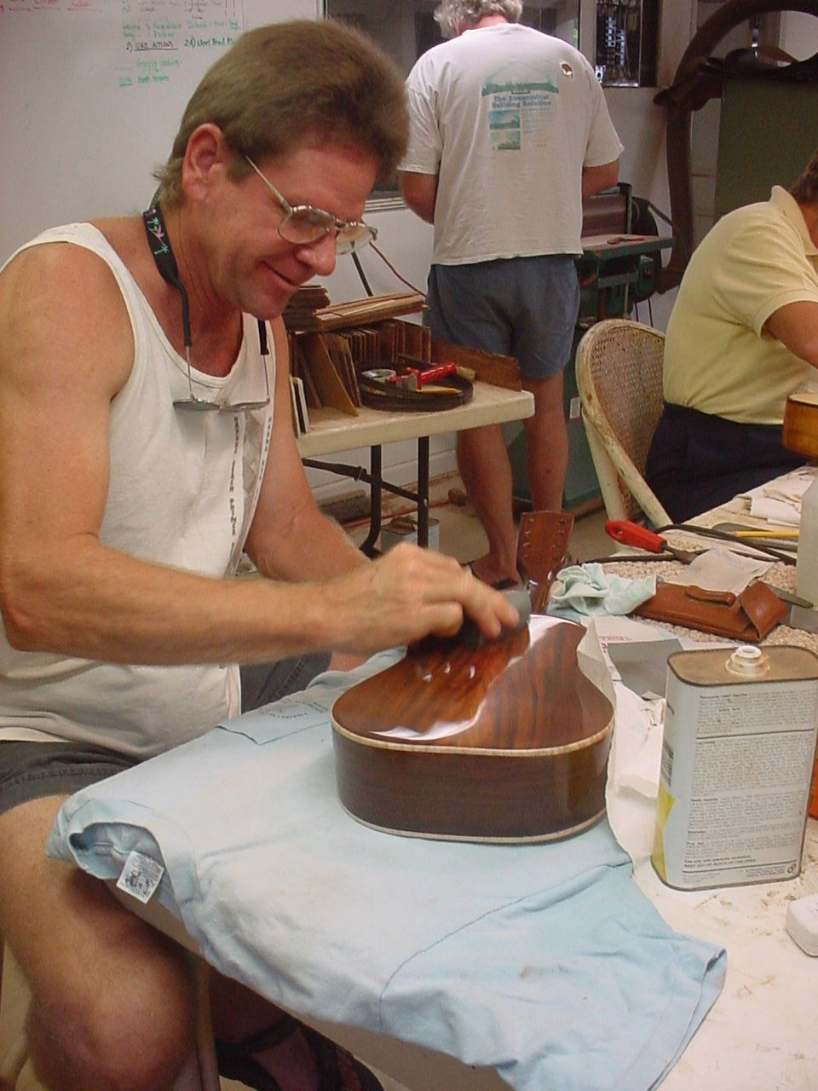
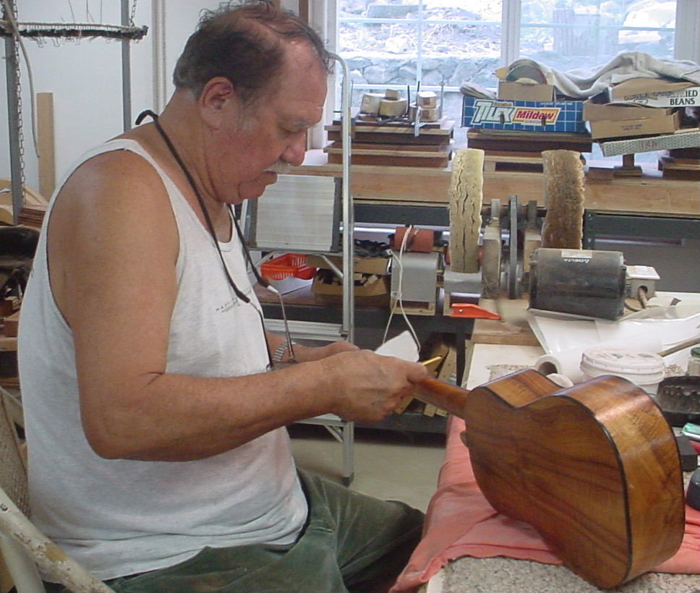
Prospective UGH member Karin Johnson - Proudly holding her 6 String Curly Koa uke with Milo binding, Pau Ferro fretboard and bridge, greenheart abalone shell rosette and purfling inlay on the top, Englemann Spruce top and smoky black Grover tuner keys. Not bad for her first uke and it sounds great! Her next uke will be a Baritone made out of Brazilian Rosewood.

UGH Member Dennis Michalske finishing up micromesh polishing of his 8 string tenor made of Milo wood, with curly maple binding, Englemann Spruce top, greenheart abalone shell rosette and gold Grover tuner keys. Almost ready to string it up and listen for that great sound.
UGH Member Mel Soares finishing application of crystalac grain filler on his beautiful curly Koa 6 string tenor uke with ebony binding, Englemann Spruce top, and greenheart abalone shell rosette. Instrument will complete by the 4th of July when we set off the fireworks inside his uke and checkout the sound!
Help Wanted

Kanile’a Ukulele is looking for a part time, flexible employee. The position requires a person to assist in the building process of their ukuleles. Please contact Joe or Kristen at 234-2868 to apply. Kaneohe, HI.
Ukulele Supply of Hawaii
Kits • Jigs • Parts • Supplies
http://ukulelesupply.tripod.com
Ph. (808) 479-1566
Email: Ukesupply@hawaii.rr.com

Wok man’s July Ono Grinds

Flamingo Crab and Avocado Quesadilla with Corona Cream

4 flour tortillas
6 oz package imitation crab
½ avocado
Green onions finely chopped
½ cup Maui onions chopped
1 cup shredded mozzarella and cheddar cheese

Corona Cream:
1 cup sour cream
2tbls. Lime juice
4tbls. Corona beer
Salt and pepper to taste.

Sprinkle ¼ cup of cheese on one of the tortillas. Overlay with crab, avocado, onions, and green onions. Sprinkle with another ¼ cup of cheese then place another tortilla over cheese. Brown quesadilla on both sides in a lightly oiled non-stick skillet. Repeat with remaining ingredience. Slot each quesadillas into four pieces and place on serving dish. Finish top by topping with the corona cream and garnish with green onions. Serve with a bottle of Corona with lime of course.

…So ono you will forget how to play that Flamingo Guitar!

Enjoy…Da Wok Man

Nate’s Shop

A while back I bought these rubbery abrasive blocks from Klingspor called schleiffix. They were designed to remove rust from metal surfaces like table saws. The concept is great as fresh, sharp bits of abrasives are continually exposed. This gave me an idea to make polishing blocks to use on high gloss finishes without the mess of excessive pumice or rottenstone powder all over the bench.

Make 2 small forms the size of soap bars (it could be just a cardboard band taped together at the ends). Scoop out enough lightweight plastic body filler to fill both forms. In one half, mix enough pumice powder to make a thick paste. The other batch would be with rottenstone. Add catalyst to each separate batch and spoon in to its respective mold. After hardened, flatten its surface on sandpaper and bench top or other flat surface. Now you have rubbing and polishing blocks that can get right up against a bridge or finger board. Better yet if you bevel the sides of these blocks. I first tried using silicone rubber and latex rubber as the bonding agents. Neither had the ‘breakaway’ properties needed to expose fresh grit.

Here’s a thought: I’m planning to make more aggressive versions of these blocks using aluminum oxide in various grits for sanding (esp. finishes). One problem: it only sells in 50 lb bags. Anyone else interested in getting some? This might even work on wood! If there’s enough interest I might even be willing to make these available to fellow members for a nominal price.

Happy Polishing!
Nate
Dba Guitarsmith, 263-2358, GuitarsmithHi@aol.com

