New Members:
Dick Hinshaw, Melvin Soares, Joseph & Kristen Souza (Kanile’a Ukulele), Daniel Raimer, Ira Glaser, Dennis Michalske, Guy Sakaki (Kona Kustom Ukes), Ted Stanton, Halemaumau Wilson, Sid Wilson, Nolan Zane and Jim Montague. Mahalos for your support folks and kudos to the Big Island once more for its inspirational membership drive.

UGH BUSINESS

Our April UGH officers meeting was held at Hana Lima Ia’s workshop, and once again we reviewed treasury funds and our Non Profit status. UGH’s coffers have about $3,700.00 in working capital and the IRS has our non profit applications and we patiently await their acceptance in a time frame of approximately 120 calendar days. We are gearing up for the November Exhibition and are still confirming, recruiting and Shanghaiing volunteers to help make this function a success. We have commitment from Big Island Master Builders and UGH will try and assemble a seminar and or lecture series to take advantage of this offer from Big Islanders Andy Berard, Bob Gleason and Dave Gomes. We will have criteria and format in July’s newsletter, which will make more specific the events and scheduling of the Ukulele Exhibition. As of late…we have a model of an Ukulele stand that seems easy to produce and designed by Mike Chock of Hana Lima Ia…the finish product will be entirely out of clear plexi glass …assuming that production costs are viable. A mock up will be brought to the June 8th general membership meeting for comments and approvals. UGH will also have copies of UKULELE GUILD membership applications that can be posted, passed out and made available to ukulele related events to get the word out to more interested parties. Once more if you have any questions, ideas, advice or comment concerning the upcoming Ukulele Exhibition, please give us a call or drop off an e-mail.

UGH WEST HAWAII REGION NEWS
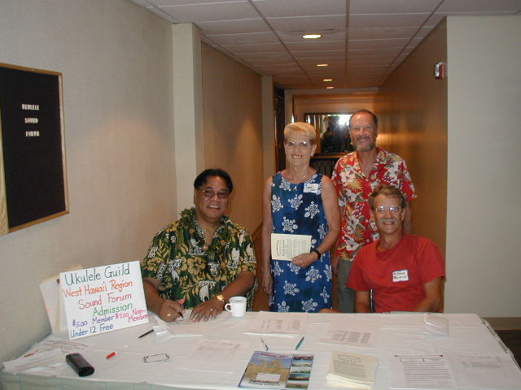
UGH West Hawaii Region News - May 31, 2002
Our hardworking members at the Registration Table: Rance Pinao, Joyce Kite, Steve Bourne, and Dick Hinshaw.
(By Andy Berard)
Our membership in the UGH continues to grow. As of May 2002 our membership in the UGH is about 25 and we continue to encourage others to join and share in our passion of lutherie. Numbers of members is great, however it is more important to have active and contributing members to make our organization strong and beneficial to all. Get the word out…mahalo.
UGH West Hawaii Region Calendar
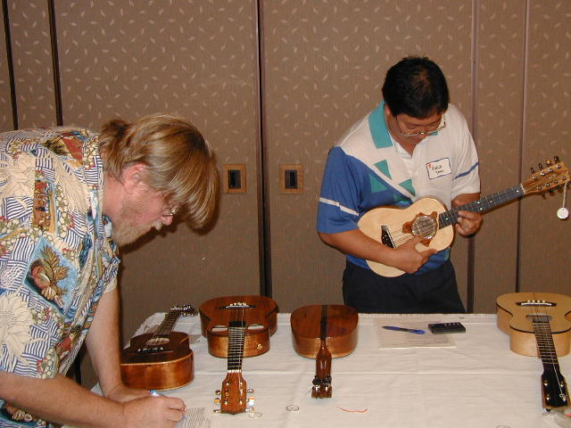
Our Next Quarterly working meeting is planned for July 13, 2002 at Andy's workshop at 1:00 p.m. Please submit workshop demonstration projects that you would like to see at our next meeting and we will try to accommodate. Also would be a good idea if you can bring one of your favorite jigs that you just can't be without for demonstration. Let me know in advance so I can arrange the agenda for time coverage.
New member to UGH, Dennis Lake, (Master Luthier) and Vince Yagi doing their part inspecting all of the beautiful ukuleles.
Remaining Working Meetings:
- October 12, 2002
UGH West Hawaii Region sound forum
Our first sound forum was held at the Ohana Keauhou Beach Hotel Kahaluu Room on 25 May 2002 from 1:00 p.m. to 5:00 p.m.
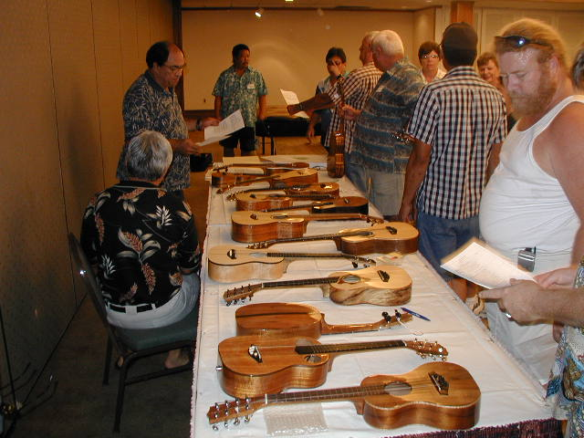
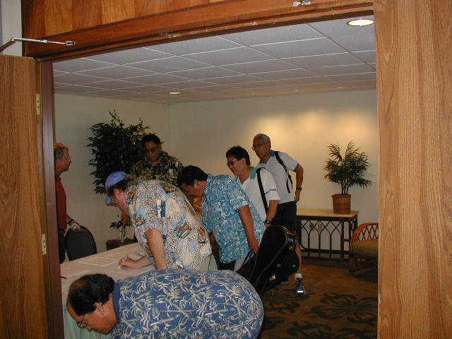
Richard Godin, foreground, inspecting ukuleles for workmanship.
Members Dennis Lake, Norman Takeya, Vince Yagi & Kimo Hussey checking in at the sound forum
We performed a workmanship evaluation on 24 beautiful ukuleles against workmanship criteria as well as an evaluation of the playability aspects of all instruments. The criteria used were compiled from Dave Gomes, Bob Gleason and Andy Berard and is a standard that we can all continue to refine as we build and pursue our ukulele building.

All ukes were tuned and tested for intonation and each builder was provided with copies of the evaluation forms for their use as a
guide in their building of ukuleles. The inspections took us a little longer than anticipated and next time we will have a pre registration time to get this work done in advance. Much mahalo to Dennis Lake, Vince Yagi, Richard Godin, Norman Takeya, Dave Gomes, & Gaylord Vermileya for assisting in this area.
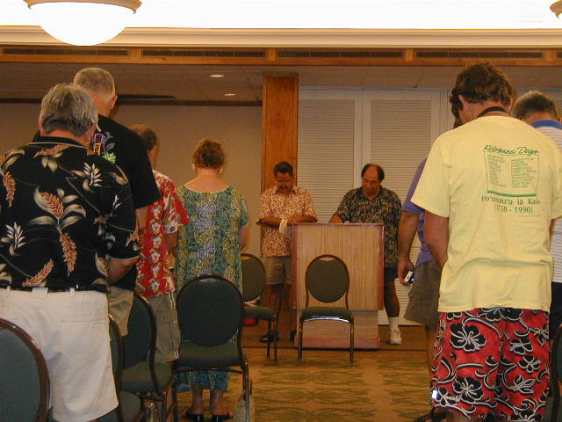
Willie Pereria leading us in our opening prayer.
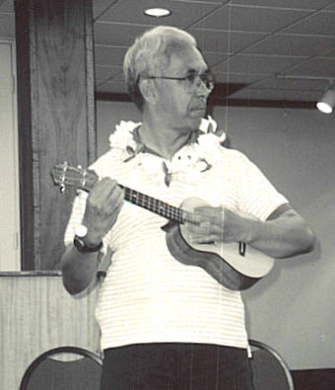
All of the instruments were evaluated prior to the starting of the sound forum phase of the program. It was so wonderful to see the high degree of professionalism and high standards used by the builders in the construction of their instruments.
Kimo playing Norman Takeya's uke with spruce top
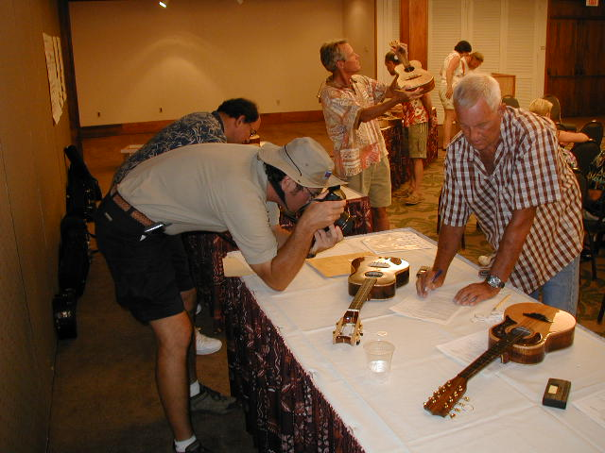
Gaylord, David, and Andy performing workmanship inspections while West Hawaii Today Reporter, Michael Darden takes picture of Ted Stanton's Brazilian Rosewood Tenor Uke.
Format for the Sound Forum
The builders were allowed to identify themselves and provide appropriate builders information such as: my first ukulele built, wood used for construction, type of strings, bracing approach, scale, type of finish, and any other factor or special recipe they used for building their instrument that they would like to highlight.

The Player will play the instrument and provide feedback in terms of its playability and sound characteristics. Playing of the same piece if desired will allow relative comparisons between similar instruments. Player may also add additional playing for a given instrument to highlight a particular instruments strong points or advantages. Following the players' evaluation, the audience was able to comment on the instrument played and ask questions of the builder or player. Total time allowed per instrument was about 5 minutes.

About the Players: A brief background of the four players who graciously helped us with playing of the instruments and characterizing the sound qualities are:

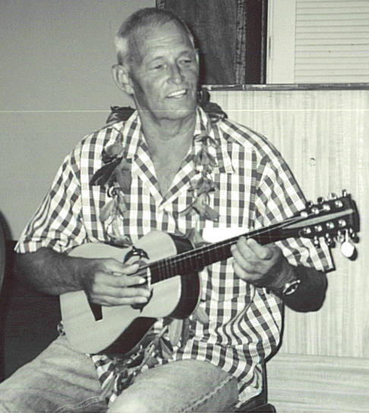
1. Kimo Hussey is a professional musician and has been playing ukulele for many years. He was one of three players at our UGH sound forum in February of this year at McKinley High School and we are so happy that he has come to our Island of Hawaii to share his playing of the ukulele with all of us. He is currently producing a video on learning to play the ukulele and how to train your ear to listen to sound and music. Place your order early with Kimo on his video.
Gaylord playing Rance Pinao's 8 String Baritone made of Milo and Engleman Spruce
2. Gaylord Vermileya is also a professional musician as well as an experienced builder of the ukulele. He currently performs at the King Kamehameha Beach Hotel and is in the process of producing a duet CD with Michael Young of Kaua`i. He also has his own business "Surfboards by Gaylord" building quality surfboards here in Kona. He has built about 140 ukuleles during his building years and today enjoys playing more than building. If you need a quality surfboard see Gaylord. You can even play your ukulele while you ride your surfboard!
3. Kekoa Nazara
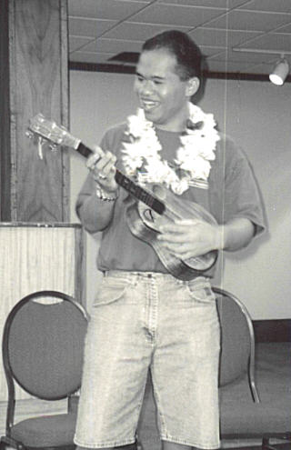
started playing the ukulele when he was very young learning from his Dad, and continuing to develop his musical playing skills through elementary and high school and into college. He presently works at the Four Seasons Resort Hualalai Cultural Center and sings and plays great ukulele for guests that are staying at the resort hotel.
Kekoa playing Willie Pereira's 6 String 2 puka all koa ukulele. Great projection, sustain and volume
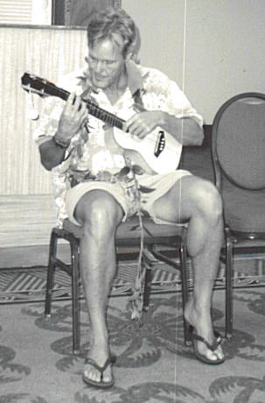
4. David Gomes is a Master Luthier who has been building ukuleles and guitars for 32 years and in business about 26 years. He plays at the Four Seasons and Kona Village as an instrumental soloist playing slack key, classical and instrumental music on the steel string acoustic guitar. If you need a quality ukulele or guitar, call David Gomes.
Dave playing Guy Sasaki's Curly Mango Uke --great sound, volume and clarity

Sound Quality
Our sound characteristics attempted to try to define as well as show example of the specific tonal or sound quality while the instruments were being played. The Five main characteristics that we used were taken from our UGH forum in February and we tried to expand on the definitions a little as follows:
Characteristic | Description/Definition
Clarity | How clear does the note sound? Are there other frequencies being heard as well as overtones and harmonics
Note Separation & Balance | The ability to hear the separation of notes when played simultaneously. The even amplitude of notes being played throughout the entire fretboard range.
Projection | The ability to hear the sound throughout the room that you are playing in. How well can you hear it in the back of the room?
Volume | How loud is the sound for a given level of strumming.
Overall Sound | How well do you like the overall tonal qualities. Kinda hard to quantify, except how you like it!

Other tonal characteristics that were discussed and pointed out during the forum are:

Characteristic | Description/Definition
High Frequency response | The instruments ability to amplify the higher frequency treble notes versus the middle or bass notes. Most instruments have a decrease of response at higher frequencies and you will hear he sound drop off in volume as you play higher on the fretboard.
Mid Range Response | The instruments ability to amplify the mid range of frequencies or notes.
Bass Response | The instruments ability to amplify the bass range of frequencies or notes.
Sustain | Ability to hear the note or notes for a time period after string is plucked. Better sustain usually associated with longer time before you don't hear the note.
Dynamic Range/  Headroom | Usually refers to the instruments ability to amplify all notes over a given range of input energy at the strings. How well does the instrument play softly and louder, then louder to the point where there is no further increase of sound output for increased sound input at the strings. In other words the amplifier reaches saturation.
Brightness | Best described as more treble with emphasis on the higher frequencies. Less mid and low frequencies
Intonation | The instruments ability to play in tune throughout the entire scale of the fretboard.

Sound characteristics are very difficult to quantify let alone get agreement about the description from individuals hearing the particular sound. We also list for you as example of the more difficult to quantify terms with no discussion and I am sure you could add to the list.

Warm | Full Sound | Big Sound
Rich in character | Smooth | Deep
Delicate | Lots of overtones | Clean Sound
Muffled sound | Hard sound | Harsh sound
Nice sound | Thick sound | sweet very nice sound
Mellow sound | Tinny sound | Bassy

In trying to get some insight into characteristics that would characterize an excellent instrument we have the following offered for your consideration:

Jake Shimabukuro (at UGH Sound forum Feb. 2002) The instrument needs to be reasonably comfortable to play, some fret buzz ok, however it must inspire him as an artist to play the instrument and keep on playing it.

David Gomes - It’s an instrument that when you pick it up to play and then play it you don't want to put it down.

Kimo Hussey - Great sound is related to the particular instrument that has all of the playability character plus good balance of strings, crisp tone, well-defined notes and great dynamic range.

Andy Berard - It is an instrument that must be comfortable to play meeting all of the playability requirements, good dynamic range, balanced, clear, great sustain and projection.

A little about the playing style of each featured performer and their characterization of sound and instruments that they played:

Starting with Kimo we have the following:
Kimos approach was to play an instrument briefly a few strums and then decide what piece would be appropriate for the instrument. He played Norman Takeya's uke with Low G tuning with side port and recently added front puka, which greatly enhanced the projection of the instrument. Characterizations for his session include: Cha langalang, accompanying type; Solo Uke which has big sound, good dynamic range where you can play softly, as well as loudly and still be heard. Clean, mellow sound, crisp tone, well defined that one can play solo, picking the melody easily and accompanying with the other chords and strumming. Very enjoyable, professional and knowledgeable regarding the ukulele and how different ones should be played.
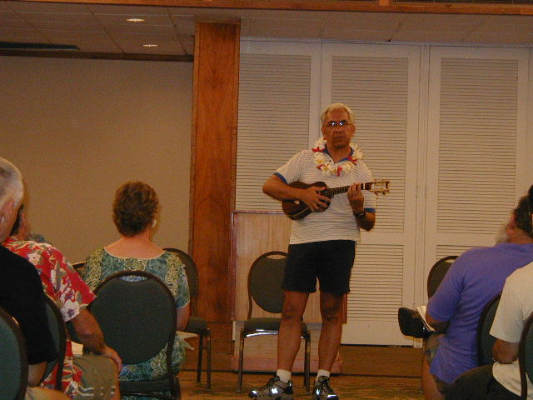
David Gomes approach was to play the same 2 pieces on each instrument and add other playing appropriate to the instruments strengths. This allowed a very good comparison between instruments. Also with Dave's experience with different tone woods and other woods used during his building career he was also able to describe the types of sound that you get with the conifer type wood such as spruce and cedar versus the other hardwoods such as koa, mango and maple. In general you will get a fuller and rounder sound with the spruce/cedar wood, clearer well defined notes and clarity of sound. Conversely, with lets say mango versus koa he has found that there is a definite sound characteristic unique to mango that he calls a mango sound that is hard to describe. One all koa instrument, with a little thicker top than desired would loose brightness and some of the roundness/fullness of the sound. Another good comparative comment was with his comparative sound between cedar and spruce. Cedar has good clarity of notes, good volume and not as much tone purity as the spruce wood. From a builders perspective Dave did an excellent job in all aspects of sound descriptions that are most beneficial for the builder especially in trying to correlate the kind of sound one is able to achieve with different tonewood for the top of the instrument. Mahalo Dave for great performance.
Kimo Hussey describing tonal qualities of Ted's uke during his performance. Great projection, mellow sound, clean. Highlighted by playing a tune with lots of picking as a good solo instrument.
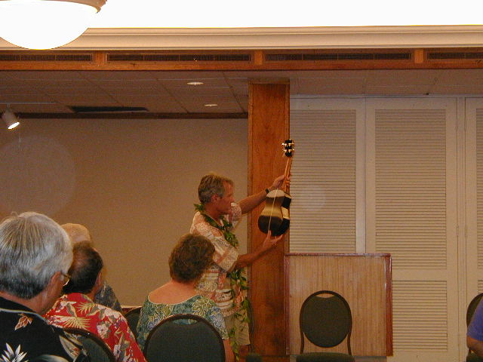
David Gomes commenting on Vince Yagi's beautiful ukulele with French polish finish. Great sound and playability. Real singing quality and excellent solo instrument
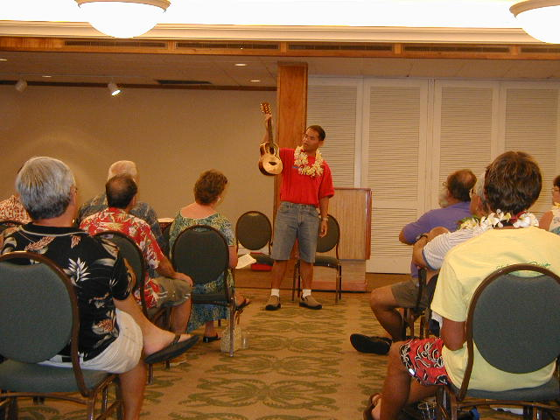
Kekoa Nazara - Kekoa's performance was also superb. I didn't tell him that only instrumental pieces would be appropriate for the playing session and am I glad that I didn't, because when he sang along with the instruments that he played, it sure added that missing element---"the voice" which is usually what the instrument accompanies! Kekoa's characterization of the ukes that he played are summarized as follows:
Kekoa Nazara during his performance evaluating one of the ukuleles and describing it as one of the Kupuna style ukes (8 String great for strumming and singing)
1. 8 String instruments Great Strumming Kupuna style ukuleles. Lots of sound and great volume…wonderful to sit down with the kupuna while you eat poke and poi…!
2. 6 String ukuleles are great background instruments say with guitar and bass and can also take the lead and easy to play with the string configuration for picking as well as strumming fullness of sound.
3. 4 or 5 Strings he likes to play solo and lead and picks the pieces appropriate for picking.

Kekoa also provided us with a very good description of picking sound, like Kapena or Nostalgic, like Moe Keale or the Kaahuanu Lake Trio sound, which he demonstrated during his playing session. Fantastic job playing and singing for his portion. Mahalo Kekoa!

Gaylord Vermileya

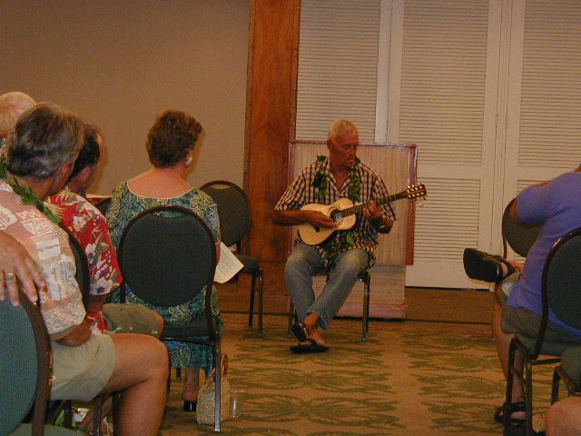
Gaylord also did an outstanding job in playing the ukes. His first one was a specialty one made by Mark Evans, which was a Tahitian style ukulele. Solid Mango Body, small ukulele sound box, and 20 pound fishing line for all 8 strings. Mark made it entirely from two pictures he saw in a magazine. Gaylord, surprisingly knew a lot about the Tahitian style ukulele and shared his knowledge of how they make them in Tahiti and also demonstrated how they had to be played, very fast and strumming style. There were two Baritone ukuleles that he played along with some tenor 8 string instruments that provided us with a good mix of builder/player assessment of sound and playability. Gaylord has big fingers and needs the wider fretboard design and bigger spacing between frets for his playing. That’s why he favors the Baritone ukuleles.
Gaylord Playing Ren's Tita Nui Baritone Ukulele - Loud & Bright, great projection.

A big big Mahalo nui loa to all of the players for sharing their special talents with us in playing each of the ukuleles and giving each instrument the time and care that they all deserve.

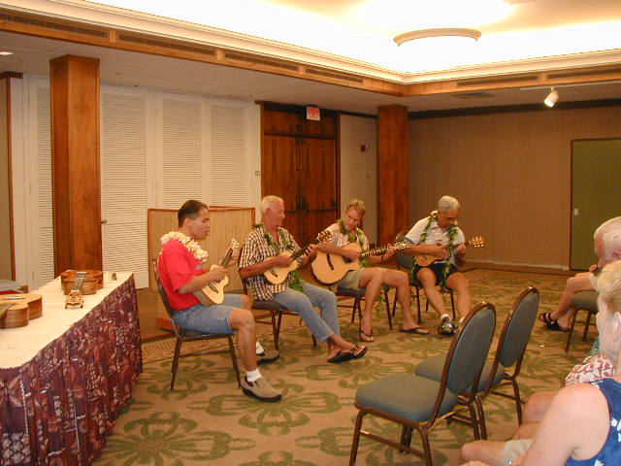
Kanikapila Time - After the playing session was pau, all four of our performers got back on stage and played beautiful music! Dave played his custom Guitar made out of curly Keawe wood with beautiful inlay and great sound, Kekoa played Guys Uke, Gaylord played his own Baritones and custom tenor made by me and Kimo played several ukes made by the builders there. Shoots, we was running out of time and only had enough time for 5 numbers before we had to stop playing. My word, we could have gone on all night!
Kanikapila Time Kekoa, Gaylord, David & Kimo jamming together

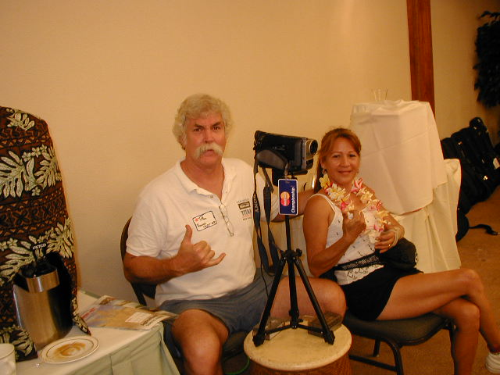
Captured on Video: We have the whole forum captured on videotape thanks to Ren and Brenda Walker. For his location in the back of the room and small microphone, the sound characteristics are very good for home made kind! I've tried to describe the forum for you in words but just can't do it justice! Contact Ren (808 326-2554 or email coverall@aloha.net) for a copy of the Video -- cost $20 and $10 cost for a CD with 98 great photos of the event. And I also need to note that 10 percent of his sales goes to our treasury for the UGH West Hawaii Region. Please, kokua and no make cheap copy. Thanks much Brenda and Ren!
Ren & Brenda Walker taking the fine pictures of the event (98 ea.) and complete video of the sound forum playing session.

Our press coverage was minimal, and only one photo of myself examining Norman Takeya's uke during the workmanship and playability portion. We are hoping for more coverage in this weekends Sunday paper. Will forward copies to our Oahu members if this happens.

Our sound forum concluded with a closing prayer by myself and the group sang Hawaii Aloha. Great Sound forum and we look forward to another great one next year.

Thanks to all of you who attended and made this event a big success. The documenting of this event certainly will go on to help us in refining our building skills as well as being able to better describe and understand sound quality and tonal aspects. Thanks to all of the players again and to our Oahu supporters Mahalo.

To all of our members who worked to put on this event great job and we all appreciate your efforts. Rance Pinao, Steve Bourne, Dennis Lake, Vince Yagi, Norman Takeya, Richard Godin, Ren Walker, Dick Hinshaw, Dave Gomes, Guy Sasaki and Ted Stanton.

Ukulele Supply of Hawaii
Kits • Jigs • Parts • Supplies
http://ukulelesupply.tripod.com
Ph. (808) 479-1566
Email: Ukesupply@hawaii.rr.com

UPCOMING EVENTS
June 8th 12 noon at Mckinley High School workshop General Membership Meeting and auction. Fret demonstration via Emil Bader and Action setup via Nate Ching of GuitarSmith

July 13 and 14th Windward Community College Ukulele Workshops
Beginning at 8:30 am till 4pm both Saturday and Sunday
Cost 150.00 for both days….125.00 before June 15th or 85.00 per day.
Players featured: Byron Yasui, Gordon Mark, Bruce Shimabukuro, Kelly Boy Fernandes, Genoa Keawe, Brother Nolan and more. Luthiers featured: Derrick Shimizu of G –String, Alan Okubo of Koaloha Ukuleles, Casey Kamaka of Kamaka Ukuleles and Mike Chock of Hana Lima Ia.

July 20th ***** this is a rescheduled Event….Binding seminar at Mckinley High School Woodshop…with Miki Browne and Mike Chock..Previously scheduled on the 13th of July this is now happening on July 20th 12 noon

Nov. 15th thru 17th First Annual Ukulele Exhibition
Marriot Waikiki Beach Hotel

Honolulu Hardwoods

Convenient Downtown Location
Ph. (808) 589-2722
1211 Kona Street

UGH FORUM
Aloha Members….Big time Mahalos to Andy Berard, Rudy “Wokman Tamayo and Nate Ching for their efforts. Andy hosted and setup with fellow West Hawaii UGH members their first Sound Forum…the Ukuleles present were awesome and the event well conceived and executed. See our West Hawaii Newsletter for in depth detail….video cassettes of this event are also available….wow! Mahalos too for the duo of Nate Ching and Wokman Rudy for hosting a Windward group meeting out at Rudy’s place. Pupus featured Rudy’s signature Chow fun…home made chicken luau via Marylene Chun, Ebony Bean Tofu Poke ala the wokman, and other ono grinds. The get together was highlighted by a member driven show and tell featuring jigs and devices brought to the gathering by fellow members. Nate Ching unleashed a host of mini touch up tools for binding channel cleanups, Vince Yagi showed his ukulele workboard jig modified and concise. Rudy demonstrated a lever setup on his oscillating sander that can thickness binding quickly and accurately. Herman Aizawa brought his taper jig that allows inlays to be accurately cut and or routed. Marylene Chun brought along a sanding block with portable sanding table to assure flat sanding…all in all the camaraderie and informational exchange was awesome. We also saw a preview of the Wokmans thickness sander…about 90 percent complete and looking really awesome..with aluminum sanding drum…geared height adjustment and of course mounted on wheels. Again mahalos for putting on a wonderful and really fun event.
Member Troy Ozama just came back from a too short visit to Japan Aside from grinding away on the ono Local Japanese foods Troy also checked out Ukulele Stores and Suppliers. He’s now back with more energy and ready to work on more Ozama Ukuleles. Also heard through the grapevine that member Richard Lessa recently finished an acoustical guitar based on a Louden Model that President Mike Browne owns and Richard admired. Well now Richard has his own Lessa Model and am told he is now happily strumming and playing his own guitar.Congradulations Richard…any Photos?

Guitarsmith
Pro-tec Tenor cases-$80.00.
Call Nate @ Guitarsmith
Ph. 263-2358

UKULELE CONSTRUCTION
By Bob Gleason
Neck Joint Tour
The subject of neck joints is sure to come up when you get a group of instrument makers together. There are many versions. They all work to some degree, thanks to modern glues. Here are a few of the possibilities and some of their good and bad points.
I judge neck joints primarily from the point of strength and their ability to be easily repaired. While I don’t want to see a neck fall off on its’ own, I do like to see a joint that can be removed in case of a repair problem. Even a well-made instrument is still a fragile commodity and unforeseeable things happen to many of these ukes we make. These days, when a uke can cost as much as a good used car, it seems important to me that we make instruments that are meant to survive for a long time. I’ve sawn apart more than a few poorly made instruments!
The most common type of neck joint used on ukes in Hawaii is one that incorporates a floating tenon.
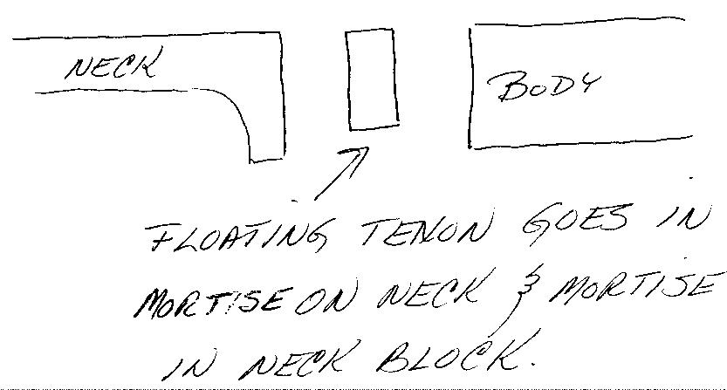

The neck and body are constructed separately and joined by a wood tenon, often plywood, that fits into a mortise on the neck heel and a corresponding mortise in the body. You can build the body and cut the mortise in the neck block with a router or tablesaw after completion of the body. Another approach is to cut the mortise in the neck block before it is glued to the sides and then later chisel away the sides to expose the slot. The main advantage of this type of joint is that it is very easy to construct. There are thousands of examples of Kamaka ukes which demonstrate that it does usually hold together. However, it is an example of one of the joints that is held together primarily by glue and as such, it can sometimes fail. To its’ benefit, it can be removed with steam if need be and is not difficult to repair. DO NOT USE EPOXY IN THIS JOINT.
A second type of neck joint, and one that is being used by a surprising number of builders today, is what I call the No Joint joint. The 1975 book, The Steel String Guitar: Repair and Construction by David Russell Young, first introduced this concept to a wide number of builders. This joint simply uses epoxy to glue the flat neck heel straight onto the body with no tenon or other type of wood reinforcement.
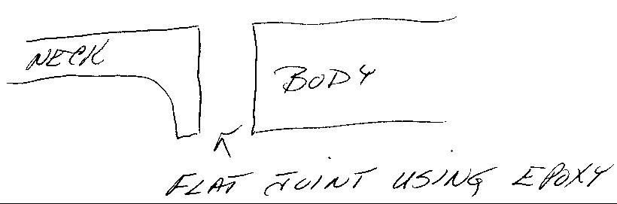
It requires little learned craftsmanship skills, is quick and easy to construct, and appeals to many builders. It is not a repairable joint and some instruments that are in need of neck removable will simply become disposable pieces. Attempts to saw the neck off often severely damage the sides or shorten the scale length of the instrument to a significant degree. If you decide to use this type of joint pay particular attention to your epoxy and epoxy mix. All epoxies are not created equal! Commonly available 5-minute epoxies, like Devcon, should never be used. Epoxies such as West System or an equivalent are the only ones that you should ever consider. You can find these better epoxies where marine supplies are sold. In addition, you must pay close attention to achieve very accurate mix ratios, as per the manufacturers instructions, or you WILL experience joint failures. Mix by weight, actually using a scale, or by accurately measured volumes only. While I do not recommend or use this type of neck joint, it does work.
A third type of joint is one that is very traditional and occasionally seen on ukes. It is most often found in classical guitar building and requires a certain degree of skill to construct. This joint uses the wood itself to provide stability to the joint in addition to the glue. The neck block is constructed as a solid one-piece extension of the neck and the sides of the instrument are let into slots cut into the neck sides.
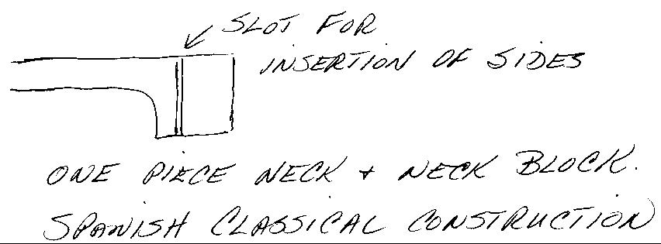

Many Spanish builders do not even glue the sides in but rather insert small wooden wedges on the inside of the instrument. While I do not use this joint in my own uke building, it is a joint that I truly enjoy making for use on traditional classical guitars. Unfortunately it requires about the same amount of skill to make this joint that it does to repair it. It is not easy to deal with in repair situations. This is another joint where epoxy should never be used.
The bolt on neck is also becoming very popular. I have seen a number of versions of it on ukuleles.
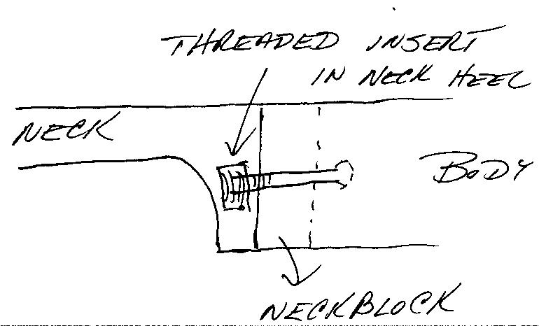

Generally a threaded insert is let into the neck heel so that a hex head or allen head bolt can be inserted from the inside of the instrument through a hole drilled in the neckblock. While this style is usually made in the same style as the No Joint joint the better versions of this joint will have some form of tenon that fits into a mortise in the neckblock. The fingerboard extension is glued to the top in the normal manner, but no glue is used in the joint area. These joints offer the ultimate ease of repair. My main objection to this joint is that it is usually very loosely fit in terms of wood contact between the neck and the body. I prefer this area of contact between the neck and body to have a very solid wood-to-wood connection. If you do use this type of neck joint, make it easily identifiable for future repair people. I once spent several hours trying to steam the neck off a guitar that had the bolt cleverly disguised under a piece of wood that looked like it was part of the neck block!
Another traditional neck joint is the dovetail joint. There are a few versions of this such as the straight dovetail and the tapered blind dovetail. The best is the tapered blind type.

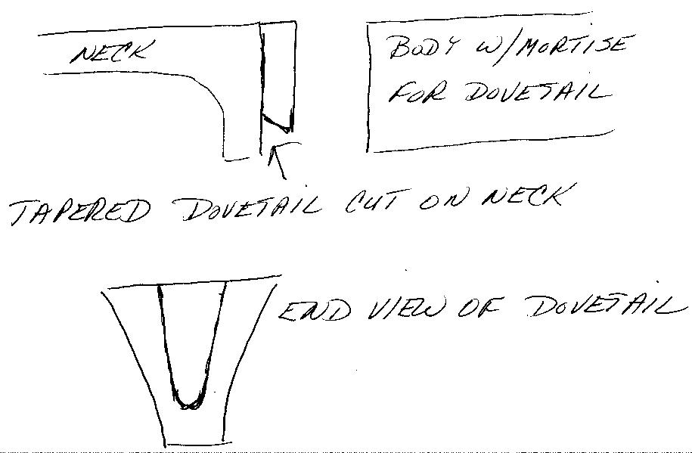

Though not often used in uke making, it is used by the Martin guitar company and a few builders like myself. While glue is used to hold the dovetail in place, the stresses caused by the string tension are actually kept in check by the structural features of the joint. A properly constructed dovetail joint could be strung up without any glue and would hold in place. If you do try this joint, remember that glue need only be applied to the sides of the dovetail. No glue is used on the area that touches the front of the instrument sides. This joint is fun to make though time consuming. It generally takes me about 2 hours to properly fit a neck and a stubborn one can take 3 or 4 hours. I particularly like this joint because it offers good continuous wood contact and is easily removed should repairs be necessary. It is normally made with a router using male and female templates affixed to the neck heel and the neck block area of the instrument.
There are many other weird neck joints made with dowels, screws, and prayers, but the ones I’ve reviewed make up the bulk of what is being done in uke construction today.
I would like to add a note of thanks to my wife Anne for proof reading and correcting these articles.

TRY DIS
For youse guys wid a passion for office supplies and cruising the Computer and Office Suppliers around town heres a tip. Canned aerosol. Yup compressed air in a spray can. Always at the ready for quick cleanouts of the ever present dust and sawdust buildups…sans the noise and racket of an air compressor. Quite a convenient device to have on hand.

For you fish lovers another must device is a simple air pump that can be used while inlay routing to provide a constant stream of air to get rid of dust and enable one to actually wear a

Pegasus Guitars and ukuleles

Ukulele sets • Ukulele Supplies
pegasus@hilo.net

Attention UGH Members:
For those of you with email, and who would not mind receiving your copy of the newsletter by email, please notify Norman at ntt815@hawaii.rr.com so that we can save on the postage.

dust mask that covers ones mouth.
No need to blow now…let that air pump do the work. For most users of the fabled Dremmel an air pump affixed to the Dremmel and a clear plexi base is a must for fine, quick and accurate routing of inlays.

MIKE’S CORNER
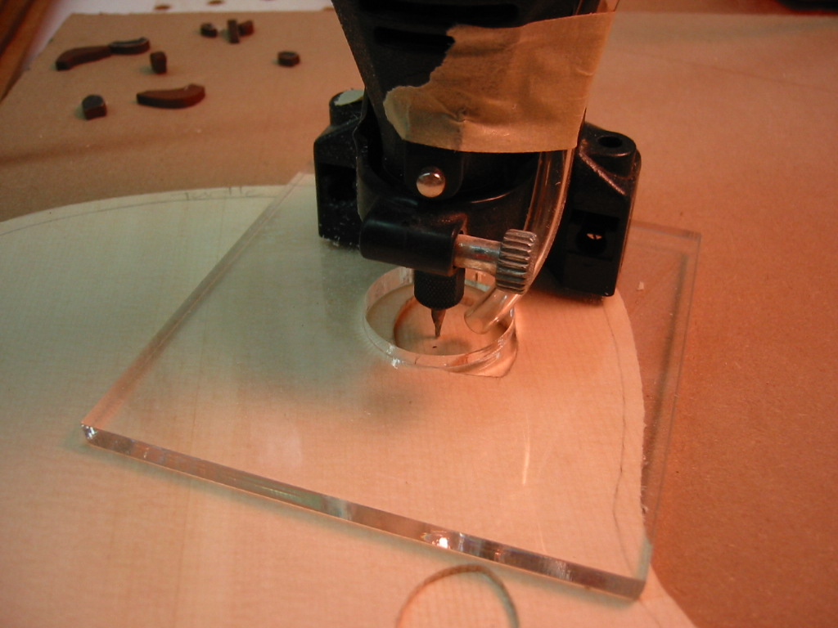
Aloha members! I know I am sounding more and more like a broken record…but once more…LARGE KINE MAHALOS TO Andy Berard and his gang out on the Big Island for their wonderful time and effort in bringing information, education and fun events to the Big Island and promoting UKULELE BUILDING with a PURPOSE. As you can see from the enclosed article the SOUND FORUM was really run well and with the sole purpose of raising the BAR in UKULELE CONSTRUCTION. We no doubt will learn a lot from seminars such as these. So once more…to the Big Island Boys…Mahalos Plenty!
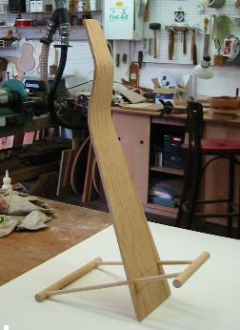
Windward Community College with its up and coming UKULELE WORKSHOPS scheduled for the 13th and 14th of July will be another must attend event. The weekend will bring together musicians and builders in a condensed format that will feature playing as well as building techiniques. Players include Byron Yasui, Gordon Mark, Kelly Boy DeLima, Brother Nolan, Bruce Shimabukuro, Aunty Genoa Keawe and others. Luthiers include Alan Okami of Koaloha Ukuleles, Casey Kamaka of Kamaka Ukuleles, Derrick Shimizu of G-String Ukuleles and Myself, Mike Chock of Hana Lima Ia. The weekend event will include pupus, a luau, both beginning and Master ukulele Workshops and plenty Kanikapila. Cost for the event is 150.00 or if you register early prior to June 15th 125.00…Call Windward Community College for more details or if you have any questions at 235-7433. They will have a schedule of events. Of course I will have a flyer on Hand extending to all interested at this event an invitation to join the Ukulele Guild of Hawaii. Now on your calendar when you mark the dates of this event make sure you circle July 20th of the following week. UGH will have a seminar and binding demonstration set for 12 noon Saturday on the 20th at Mckinley High School. This event has been rescheduled to make room for the Windward Community College Seminars. But come Saturday the 20th president Miki Browne will have her Binding jig at the ready and demonstrate binding cuts. I’ll have my trusty laminate trimmer to also demonstrate binding cuts the low-tech way…. should be fun.
So I doth end with this and pray that we all keep our G-strings tight! Till next month…laters mike

Ukulele stand prototype
Yep been busy in the shop…final stand will be out of clear Plexiglass and Plexi dowels…better to show off yer Uke.

Notable Woods
Bruce Creps, Box 3549, Eugene, Oregon 97403
Ph/Fax 541-344-9888
email bruce@notablewoods.com
web: www.notablewoods.com
Plenty of good ukulele wood: Koa, Claro walnut, figured maple, Sitka spruce.
Free Freight to UGH members.

